**Mini Project 1** (Solutions)

**Section 1**

1. In this problem we use the KNN classification method on the training data set and predict the classes of the test data set.
   1. knn() function was used for the K values = seq(1, 496, by = 1)
   2. 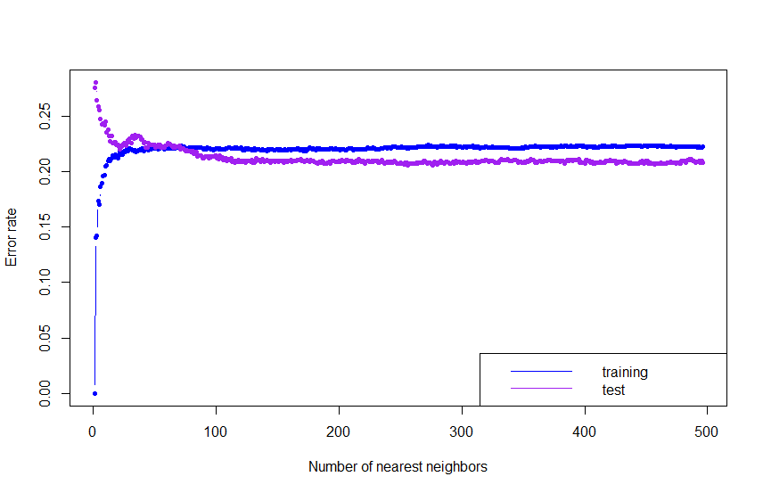Training and test error rates were calculated for different K values and they were plotted against K values as follows.

The plot expected to have a concave up curve for test error rates and concave down curve for training error rates, separated from the $var(ϵ)$ horizontal line and they do not cross over each other. This seems to be true in the region $0≤K<50$ but when K is increased, the test error rates curve cross over the other.

* 1. Optimal value of K is found by finding the minimum value of test error rates and there were two K values that minimizes the test error rates, K = 256 and K = 276 . Associated training and test error rates for optimum K values are shown on the following table.

|  |  |  |
| --- | --- | --- |
| ks | err.rate.train | err.rate.test |
| 256 | 0.2221 | 0.206 |
| 257 | 0.2226 | 0.206 |

* 1. Since we had two K values that makes the test error rate minimize, corresponding decision boundaries were plotted separately as follows.

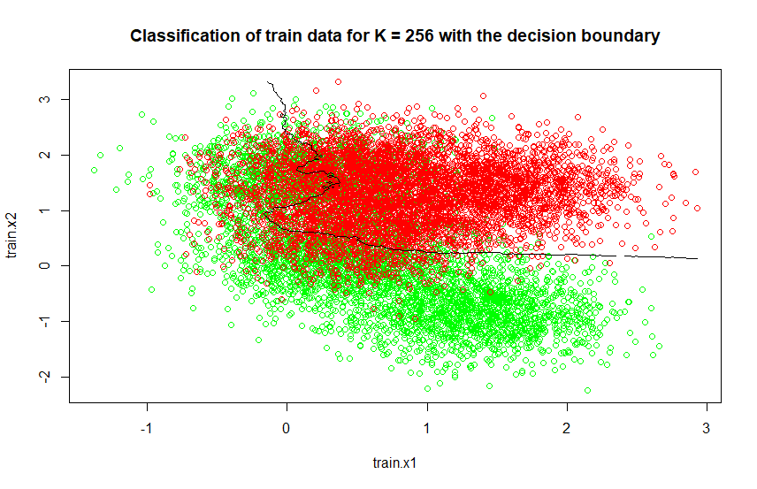

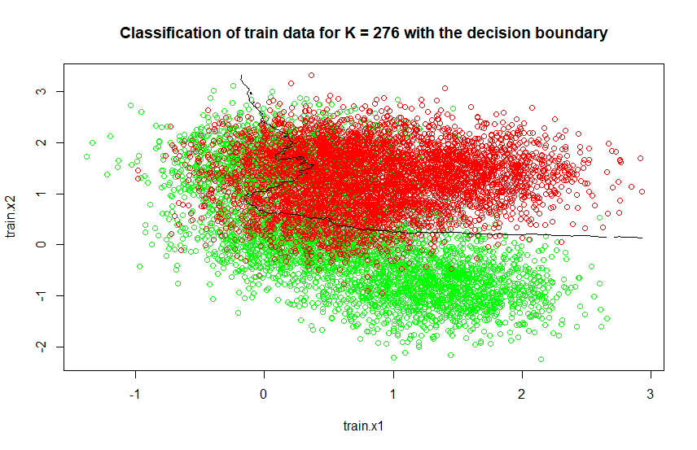

1. 1/5th of the data set e CIFAR-10 were used to classify using KNN method with K = 50, 100, 200, 300, 400.
   1. Following table shows the error rates for different K values.

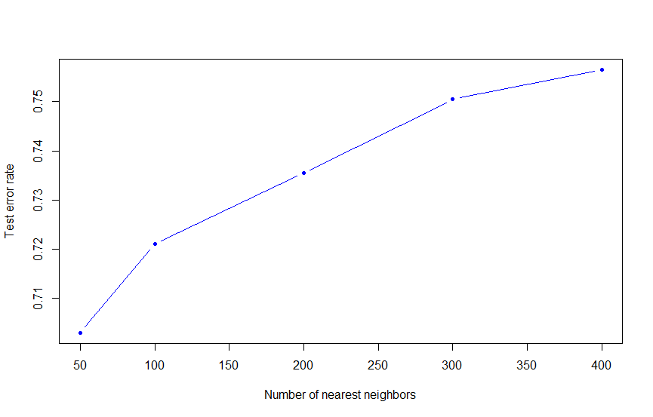

|  |  |  |  |  |  |
| --- | --- | --- | --- | --- | --- |
| ks | 50 | 100 | 200 | 300 | 400 |
| err.rate.test | 0.7030 | 0.7210 | 0.7355 | 0.7505 | 0.7565 |

* 1. Minimum error of test error rate was 0.7030 and the associate K value was 50. Below is the confusion matrix.

y.test

mod.test 0 1 2 3 4 5 6 7 8 9

0 117 11 31 9 4 5 4 6 19 6

1 0 7 0 1 0 0 0 0 0 2

2 16 25 66 31 26 42 32 34 8 16

3 1 2 2 17 0 6 1 4 0 1

4 32 55 94 81 120 78 86 93 16 49

5 0 3 1 8 0 30 0 5 4 2

6 4 25 10 33 6 21 51 13 5 12

7 1 2 1 2 0 2 1 20 2 5

8 44 62 10 20 12 11 10 25 137 101

9 0 6 1 2 0 1 2 4 1 26

* The KNN classified 2000 data into 10 classes.
* Accuracy of the classifier $= 591/2000 = 0.2955$
* Misclassification rate $= 1 - 0.2955 = 0.7045$
* Sensitivity of each class

|  |  |
| --- | --- |
| Class | Sensitivity |
| 0 | 117/215 = 0.5442 |
| 1 | 7/198 = 0.0354 |
| 2 | 66/216 = 0.3056 |
| 3 | 17/204 = 0.0833 |
| 4 | 120/168 = 0.7143 |
| 5 | 30/196 = 0.1531 |
| 6 | 51/187 = 0.2727 |
| 7 | 20/204 = 0.0980 |
| 8 | 137/192 = 0.7135 |
| 9 | 26/220 = 0.1182 |

* 1. Since the optimum K value is unknown, we need to check several K values. As shown in part a) even to get an approximation for the optimum K is a bit tricky. Also for a large data set like CIFAR-10, the computation time for KNN was high. By looking at the sensitivity of each classes, only few classes were classified with high probability. Thus we can’t guarantee that KNN is a good classification with this data set.

Section 2

**# problem 1**

library(class) # for knn

training.data <- read.csv(file.choose(), header = T) # Get the training data

test.data <- read.csv(file.choose(), header = T) # Get the test data

# seperate the data as train and test for knn

set.seed(1)

train.X <- cbind(training.data$x.1, training.data$x.2)

train.Y <- training.data$y

test.X <- cbind(test.data$x.1, test.data$x.2)

test.Y <- test.data$y

# part a)

ks <- seq(1, 496, by = 1) # set the K values for KNN

nks <- length(ks)

# create vectors to store train and test error rates

err.rate.train <- numeric(length = nks)

err.rate.test <- numeric(length = nks)

names(err.rate.train) <- names(err.rate.test) <- ks

# set KNN for train and test data

for (i in seq(along = ks)) {

set.seed(1)

mod.train <- knn(train.X, train.X, train.Y, k = ks[i]) # KNN for train

set.seed(1)

mod.test <- knn(train.X, test.X, train.Y, k = ks[i]) # KNN for test

err.rate.train[i] <- mean(mod.train != train.Y) # calculate train error rate

err.rate.test[i] <- mean(mod.test != test.Y) # calculate test error rate

}

# plot train and test error rates against K values

plot(ks, err.rate.train, xlab = "Number of nearest neighbors", ylab = "Error rate", type = "b", ylim = range(c(err.rate.train, err.rate.test)), col = "blue", pch = 20)

lines(ks, err.rate.test, type="b", col="purple", pch = 20)

legend("bottomright", lty = 1, col = c("blue", "purple"), legend = c("training", "test"))

# part c) calculate minimum of test error rates

result <- data.frame(ks, err.rate.train, err.rate.test)

optimal.point <- result[err.rate.test == min(result$err.rate.test), ]

# > optimal.point

# ks err.rate.train err.rate.test

# 256 256 0.2221 0.206

# 276 276 0.2226 0.206

# part d)

n.grid <- 200

x1.grid <- seq(f = min(train.X[, 1]), t = max(train.X[, 1]), l = n.grid)

x2.grid <- seq(f = min(train.X[, 2]), t = max(train.X[, 2]), l = n.grid)

grid <- expand.grid(x1.grid, x2.grid) # grid to plot the decision boundary

# 1st plot with K = 256

k.opt <- optimal.point[1,1] # 256

set.seed(1)

mod.opt <- knn(train.X, grid, train.Y, k = k.opt, prob = T) # KNN with K = 256

prob <- attr(mod.opt, "prob") # prob is voting fraction for winning class

prob <- ifelse(mod.opt == "yes", prob, 1 - prob) # now it is voting fraction for Direction == "Up"

prob <- matrix(prob, n.grid, n.grid)

plot(train.X, col = ifelse(train.Y == "yes", "green", "red"))

contour(x1.grid, x2.grid, prob, levels = 0.5, labels = "", xlab = "", ylab = "", main = "", add = T)

# 2nd plot with K = 256

k.opt <- optimal.point[2,1] # 276

set.seed(1)

mod.opt <- knn(train.X, grid, train.Y, k = k.opt, prob = T) # KNN with K = 276

prob <- attr(mod.opt, "prob") # prob is voting fraction for winning class

prob <- ifelse(mod.opt == "yes", prob, 1 - prob) # now it is voting fraction for Direction == "Up"

prob <- matrix(prob, n.grid, n.grid)

plot(train.X, col = ifelse(train.Y == "yes", "green", "red"))

contour(x1.grid, x2.grid, prob, levels = 0.5, labels = "", xlab = "", ylab = "", main = "", add = T)

**#problem 2**

library(class) # for KNN

library(keras) # for cifar10 data

cifar <- dataset_cifar10()

str(cifar)

x.train <- cifar$train$x

y.train <- cifar$train$y

x.test <- cifar$test$x

y.test <- cifar$test$y

# reshape the images as vectors (column-wise)

# (aka flatten or convert into wide format)

# (for row-wise reshaping, see ?array_reshape)

dim(x.train) <- c(nrow(x.train), 32*32*3) # 50000 x 3072

dim(x.test) <- c(nrow(x.test), 32*32*3) # 50000 x 3072

# rescale the x to lie between 0 and 1

x.train <- x.train/255

x.test <- x.test/255

# categorize the response

y.train <- as.factor(y.train)

y.test <- as.factor(y.test)

# randomly sample 1/5 of the data to reduce computing time

set.seed(1)

id.train <- sample(1:50000, 10000)

id.test <- sample(1:10000, 2000)

x.train <- x.train[id.train,]

y.train <- y.train[id.train]

x.test <- x.test[id.test,]

y.test <- y.test[id.test]

# part a)

ks <- c(50, seq(100, 400, by = 100)) # set K values for KNN

nks <- length(ks)

err.rate.test <- numeric(length = nks)

names(err.rate.test) <- ks

# set KNN for test data

for (i in seq(along = ks)) {

set.seed(1)

mod.test <- knn(x.train, x.test, y.train, k = ks[i])

err.rate.test[i] <- mean(mod.test != y.test)

}

> err.rate.test

50 100 200 300 400

0.7030 0.7210 0.7355 0.7505 0.756

plot(ks, err.rate.test, xlab = "Number of nearest neighbors", ylab = "Test error rate", type = "b", ylim = range(c(err.rate.test)), col = "blue", pch = 20)

# part b)

result <- data.frame(ks, err.rate.test)

optimal.point <- result[err.rate.test == min(result$err.rate.test), ]

> optimal.point

ks err.rate.test

50 50 0.703

> mod.test <- knn(x.train, x.test, y.train, k = 50) KNN for K=50

> table(mod.test, y.test) # confusion matrix

y.test

mod.test 0 1 2 3 4 5 6 7 8 9

0 117 11 31 9 4 5 4 6 19 6

1 0 7 0 1 0 0 0 0 0 2

2 16 25 66 31 26 42 32 34 8 16

3 1 2 2 17 0 6 1 4 0 1

4 32 55 94 81 120 78 86 93 16 49

5 0 3 1 8 0 30 0 5 4 2

6 4 25 10 33 6 21 51 13 5 12

7 1 2 1 2 0 2 1 20 2 5

8 44 62 10 20 12 11 10 25 137 101

9 0 6 1 2 0 1 2 4 1 26